Pollinators Around Us!

Grade Level(s) 2nd Grade
Estimated Time 30 minutes
Purpose
Students will discover there are a variety of pollinators around us. Students will learn how pollination plays a very important role in a plants life cycle.
Materials
▪ Bee Ag Mag
▪Pipe Cleaners
▪Tissue Paper
▪Plastic bag
▪Be Your Own Pollinator, Take Home Activity

Links:
River Bend Ag in the Classroom April Lesson: www.riverbendaitc.com/april
Intro Video: Pollination and Pollinators - Davenport Event - YouTube

Vocabulary
Agriculture: The science or practice of farming, including cultivation of the soil for the growing of crops and the raising of animals to provide food, wool, and other products.
Pollinator: an insect or animal that conveys pollen to a plant and so allos fertilization.
Pollination: is the transfer of pollen.

Interest Approach – Engagement
Ask the students to list off pollinators.
Example: Honeybees, Butterflies, Beetles, Birds
Background - Agricultural Connections
Pollination is a very important part of the life cycle of plants. Plants cannot produce seeds unless they are pollinated. Some seeds provide food for people. Other seeds provide food for animals or industrial uses, like fuel or fiber for clothing.
Pollination is the transfer of pollen. Pollen are microscopic, powder-like grains produced in the stamen (the male reproductive organs of a flower). During pollination, pollen is transferred from the stamen to the pistil (the female reproductive organs) of a flower. Once the male and female cells unite, the plant can produce.
Procedures
1. Make a list as a class of pollinators you know of.
2. Ask the students if they know how honey is made.
Honeybees collect the pollen and nectar for the plant. Honeybees then take the pollen and nectar to their hives where they then make it into honey.
3. Watch the video, Pollination and Pollinators. Review the video and answer common questions.
4. Hand out the Bee Ag Mag. Have students read individually or with a partner. Transition to other common pollinators. Butterflies!
5. Pass out the bag butterfly materials.
Directions:
- Your butterfly will be made by filling a Ziploc bag with colored tissue paper. If you are using paper or cellophane, cut into small pieces.
- Place the tissue paper into the bag. Leave about an inch of the Ziploc bag unfilled.
- Seal the Ziploc bag and fold the unfilled portion of the bag to the back of your butterfly.
- Wrap a pipe cleaner around the middle of your bag and twist it at the top. Shape the pipe cleaner to make it look like antennae.
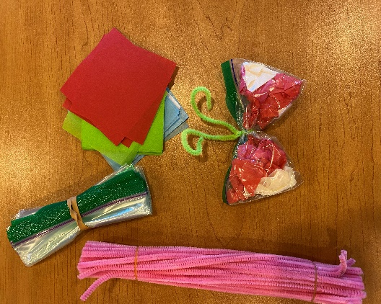

6. Send Be Your Own Pollinator activity home with the students.

Organization Affiliation
Rebecca VanderHeiden, River Bend Ag in the Classroom Coordinator

Iowa/ Common Core Standards
SS.2.12: Identify how people use natural resources to produce goods and services.
SS.2.17: Explain how environmental characteristics impact the location of particular places.
2-LS2-2: Develop a simple model that mimics the function of an animal in dispersing seeds or pollinating plants.

