Dress Up Like A Corn Plant

Target Grade Level / Age Range:
Kindergarten

Time:
Reading: 10 minutes
Presentation: 20-25 minutes.

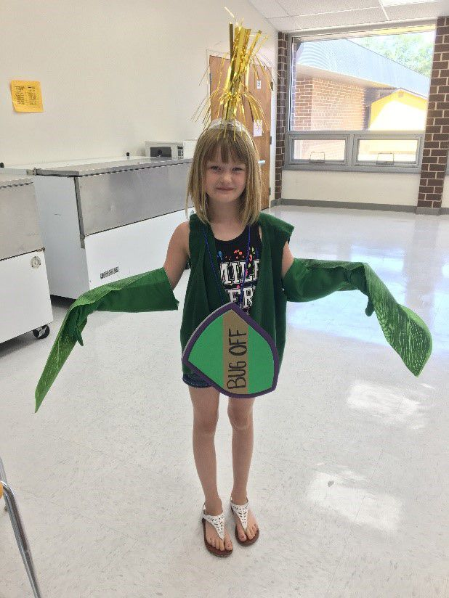

Purpose:
To teach students about the life cycle of corn and explain the steps a farmer takes to grow and harvest a product.

Materials:
- My Family’s Corn Farm by Katie Olthoff
- Dress up materials:
  - Brown fleece
  - Green fleece
  - Green vest
  - Brown vest
  - Blue craft pom poms
  - Ping pong balls
  - Seed photo
  - Sun photo
  - Foam toy shield
  - Pipe cleaners OR yellow tabletop tassel decoration attached to a headband
  - Three colors of foam sheets OR pre-cut foam letters (N, P, and K)
  - Long green gloves OR green felt cut in leaf shapes
  - Pop bottle
  - Yellow tissue paper
  - White yarn
  - Green felt
  - OPTIONAL: poop emoji pillow or toy
  - Ear of dent corn

Suggested Companion Resources (books and websites)
- My Family’s Corn Farm Book by Katie Olthoff
- Corn Lifecycles by Julie Murray
- Corn by Gail Gibbons
Vocabulary (with definitions)
- Corn: also known as Maize. A tall cereal plant.
- Kernels: the seed of corn
- Planter: machine that evenly spaces kernels out in rows in a field
- Soil: the upper layer of the Earth in which plants grow
- Germination: the step a seed goes through to become a plant. Requires heat and moisture.
- Irrigation: A technology that supplies water to land or crops to help them grow.
- Stalk: The main stem of a corn plant.
- Tassel: the top of the corn plant that produces pollen to pollinate the silk on the ear of corn.
- Silk: the threadlike part of the ear of corn that produces each individual kernel when pollinated.
- Pollination: the transfer of pollen to produce a seed.
- Nitrogen: one of the essential nutrients to corn.
- Phosphorous: one of the essential nutrients to corn.
- Potassium: one of the essential nutrients to corn.
- Weather: the state of the atmosphere that produces sun, rain, wind, hail, sleet, snow.
- Insecticide: a substance used to protect plants against insects.
- Spring: time of the year when farmers plant corn
- Summer: time of the year when corn grows
- Fall: time of the year when farmers harvest corn
- Harvest: the process of removing the ear of corn from the plant
- Combine: the machine used to harvest corn. This machine has multiple jobs in one from cutting the corn, to shucking the cob from the plant, to removing the kernels from the cob.
- Field/Dent Corn: 99% of the corn grown in Iowa.
- Ethanol: a renewable fuel that is made from corn and powers our cars.

Background – Agricultural Connections (what would a teacher need to know to be able to teach this content)
This lesson was created as a presentation-style lesson to demonstrate the life cycle and parts of a corn plant. The lesson starts by reading the book My Family’s Corn Farm by Katie Olthoff, and then uses a volunteer and numerous materials to dress up the student as if they were a corn plant. In these instructions, each step that has a prop is bolded.
Corn is a monocot plant that has many purposes. Much of it becomes livestock feed and ethanol fuel, or is exported as value-added products. But corn is used in over 4,000 edible and nonedible products. It helps make shampoo, gum, marshmallows, plastic, tooth brushes, and much more.
The United States is the world leader in corn production, growing 13.6 billion bushels in 2015. Iowa is the number one producer of corn in the nation. In 2015 Iowa produced 2.5 billion bushels of those 13.6 billion bushels of corn. The corn being produced is called field or dent corn. This is different than sweet corn. 99% of the corn grown in the United States is field corn and less than 1% is sweet corn.
The corn life cycle is a process that begins in the early spring around mid-April in Iowa. This is the time of the year where farmers are preparing for planting season by getting equipment out such as planters, tractors, and different types of tilling attachments. Farmers will previously have purchased their seeds that they will use to plant the year’s crop. *To demonstrate that the volunteer in the lesson is a kernel, use a printed photo of a corn kernel.*
The planter is the machine that farmers will place bags of seed in the holding chambers. As the planter moves across the field, it slices open the soil and makes a trench. Then the seed that is being held in the chamber falls through a series of sensors and is precisely placed in the soil. Corn is planted at a depth of 1 ½ to 2 inches. The corn seed is spaced out about 4-6 inches apart. To see how a planter works, check out this link: http://www.sdcorn.org/2013/05/how-does-a-corn-planter-work/. After the seed is placed in the soil the planter finishes by covering the trench it made with soil covering the seed. *To illustrate that the kernel is covered in soil, use a relatively large piece of brown fleece, or a dark-colored blanket or towel. *
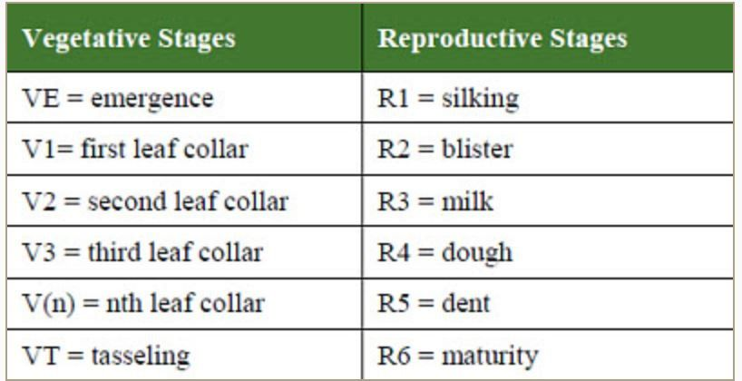The next step the corn kernel takes is germination. A seed needs two things to germinate: heat and moisture. The seed will begin to absorb water and swell. The seed gets moisture from rain. In Iowa, we receive rainfall regularly so farmers do not need to irrigate their fields. In other states or environments that are drier, irrigation is a common practice used. If weather conditions are not optimal, it can stunt germination and growing. Germination and emergence are dependent on temperature, especially soil temperature. The seed gets heat from the sun as it continues to warm up theground. As the seed gets heat and moisture it elongates and emerges from the soil. *In the presentation, to help your volunteer germinate, use a printed photo of the sun as a heat source and blue craft pom poms as rain.*
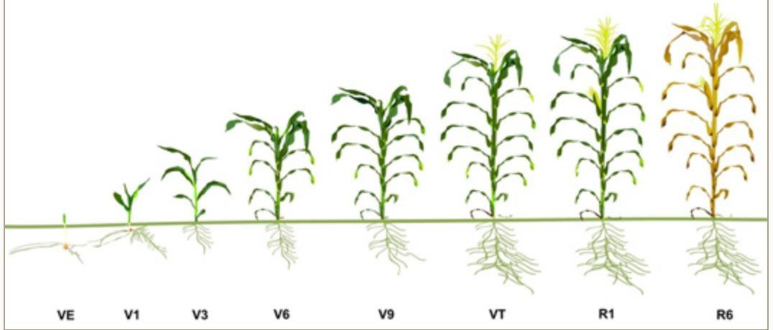There is a series of growth and development stages corn will go through. Figure 1. presented by Dupont Pioneer explains the vegetative stage along with the reproductive stage. Figure 2 gives a visual of the corn growth stages. For more information on the vegetative and reproductive stages, check out this link: http://www.soilcropandmore.info/crops/Corn/How-Corn-Grows/.
As the corn plant matures, it will grow more leaves and will turn dark green in color. *To help illustrate this, give your volunteer a green vest or T shirt and leaves.* Leaves can be made by cutting out felt and having the student hold them, or by attaching them to gloves. More leaves can be added by attaching them to the vest, if you would like to add them.
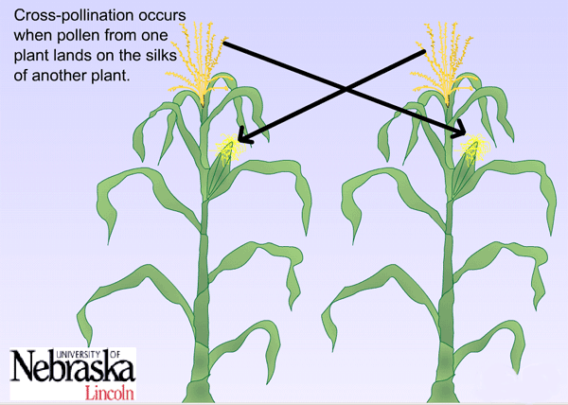The next step that is important to corn production is the pollination of corn. Corn plants can self-pollinate but typically cross pollination occurs in fields of corn. The silks of an ear of corn are pollinated by pollen that falls from the tassel of the surrounding corn plants. The silk is attached to one kernel of corn on the ear and when pollen falls on the silk it travels down and pollinates the kernel of corn. On average, there is about 800 kernels of corn on the cob, meaning there are 800 silks waiting to be pollinated. *To display the tassel, use either yellow pipe cleaners attached to a headband, or glue a metallic table centerpiece (available at a party store) to a headband. To display the ear, use a clear water bottle or pop bottle, stuff it with yellow tissue paper, and glue some short lengths of white or pale yellow yarn to it to display silks. Then, use some more green felt leaves to wrap a portion of the bottle like the husk of the ear. *
Once the ear of corn has been pollinated and the kernels begin to develop they also go through a series of stages until the kernels develop into the final stage. This stage is known as the Dent stage and this is where this type of corn gets its name, field/dent corn. As the kernels mature, they begin to dry out which causes the kernel to develop dents at the top of the kernel.
As the end of the growing season comes to an end, corn begins to drop down to lower moisture levels. When a farmer goes to harvest corn, he or she has a few considerations. A farmer knows that the corn is ready when the plant stops filling the kernel with starch, and the tip of the kernel is closed off from the cob. This can be seen when the tip is broken off the kernel, and is called the black layer . At this time, the corn is dead and continues to dry in the field. This is when the corn plant turns brown. *To demonstrate maturation, use a brown vest or T shirt (like the green one used earlier).*
Once corn has reached the black layer stage, the moisture of the kernels becomes a determining factor. The moisture is affected by factors like temperature, rainfall, and humidity. Farmers can test the moisture of the corn by running it though a moisture tester . The average kernel at black layer will be 30% moisture. Corn can be harvested at 30% moisture but not be stored unless it is around 15% moisture. Farmers may choose to harvest wetter corn at 20%-30% moisture and use a grain dryer to dry the corn down to an acceptable storage moisture level. Some farmers may choose to wait for the corn to dry down in the fields, but this takes valuable time. If corn is harvested too early, the farmer must pay for the drying costs to lower the moisture. The stalks can also be tough and hard for the combine to harvest. If corn is harvested too late, the ears may fall off the plant or the stalks may fall over, making it more difficult to combine them. Waiting too long to harvest corn incurs more loss of grain in the field.
This explains the growth and development process of the corn life cycle, but that does not cover the entire equation farmers go through during the growing season. There are many additional factors farmers must be aware of to grow a successful crop. Farmers’ corn fields deal with many different environmental factors like weather conditions, insects/predators, and a variety of other factors. When a farmer notices a problem in their fields they will take precautions or steps to protect their crops.
Weather is a big factor that farmers deal with on a regular basis. Weather events like drought, excess rain, storms, hail, or wind can be issues for crop farmers. The weather is out of the farmers control, so farmers have to know the proper precautions to take. The only way to take a precaution on this factor is for a farmer to sign up for certain types of crop insurances. A major crop insurance is hail insurance. Hail and wind can be very destructive to a field of corn. Hail can puncture the corn plants and stunt the corn’s growth. Wind can flatten corn fields and either stunt the growth or kill off the plant all together. *To demonstrate hail, use ping pong balls. To demonstrate high winds, have your class blow towards the volunteer! *
Insects are another factor that farmers must deal with. There are a variety of insects that feed on corn plants. There are insects that feed on the roots, the stalk, the leaves, or elsewhere on the plant. A precaution a farmer can take prior to planting is selecting a certain type of seed that is resistant to insects. This is known as a genetically modified organism (GMO). Another way to deal with pests like insects is to apply an insecticide. A farmer will only apply an insecticide if he/she notices a pest/insect in the corn field that is destructing the crop. *To demonstrate a bug, you could use a toy insect. To demonstrate protecting the corn plant with insecticides, use a toy foam shield and/or foam sword.*
Farmers will also apply fertilizer to their crops to help aid in the growing process. Corn has three main macronutrients (nutrients needed in the highest quantity) that it needs to grow. These nutrients are nitrogen (N), phosphorus (P), and potassium (K). Farmers apply fertilizer by selecting the right source, right rate, right timing, and right placement. Farmers never want to apply more fertilizer than what is needed because of environmental factors and the cost associated to apply additional fertilizer. They only apply fertilizer where the plants are not getting sufficient nutrients. Fertilizer can come in many forms. Some forms, like anhydrous ammonia (for nitrogen) are purchased from a cooperative. Other forms, like manure from livestock, may be something the farmer already has on hand. Manure is very high in nitrogen, and contains high levels of phosphorus and potassium. *To display the application of fertilizers, cut out the letters N, P, and K from different colors of foam sheets, or use foam letter stickers. To display the use of manure, any toy featuring the poop emoji (such as a pillow) would work.*
Growing a corn crop takes a lot of factors to guarantee a successful crop, but this is all a part of the corn life cycle that farmers go through each season.

Interest Approach or Motivator
Ask students what they know about corn plants. What are the parts of a corn plant? What happens to a corn plant throughout the year?

Procedures
Begin the class period by reading the book My Family’s Corn Farm by Katie Olthoff. Tell students to pay attention to things like parts of the corn plant and the life cycle of the plant while you read the book aloud.
Next, follow along with the script below to proceed with the dress up activity.
Today we are going to learn about how a kernel of corn grows up to be a 12ft corn plant.
It all begins in a certain season of the year.
Presenter: Can anyone tell me when we plant corn?
Answer: SPRING
Spring is the time of the year when the soil is warming up from the cold winter months and plants and animals are waking up and starting to grow. In Iowa during the spring, you can see farmers preparing tractors and these big machines called planters. Planters are used to place the corn seed in rows and evenly space them out so they have enough room to grow.
Presenter: Now why do you think it’s important to know why we grow corn?
Answer: Because corn is in over 4,000 of our daily items we use like shampoo, cell phone cases, and tooth paste. Corn is used to sweeten our pop and candy, make pudding thicker, and keeping pizza crust from getting soggy.
Presenter: So, do you think it’s important to grow corn?
Answer: Yes
Presenter: Do you think it’s a lot of work to grow corn?
Answer: Yes!
Well, let me take you on a journey that shows how one kernel can grow up to make a big difference. In order to show you how a corn kernel grows up we are going to need a volunteer to dress up as corn plant.
SELECT ONE STUDENT
***(Ask for the student’s name. Their name becomes the main character of the story)
The Story and Life of _________ (*Insert Students Name) the Corn Plant
Our story begins with one corn kernel named ____.
***(Hand the laminated seed kernel to student to hang on to.)
_____ is one of many corn kernels in a bag of corn that is waiting to be planted. Now remember how we talked about what a planter is? (It’s the big machine that spaces corn kernels out in a big field to plant them) _____will get put in one of the holding chambers in the planter and as the planter is moving across the field it will cut open the soil and drop a kernel down every 6 inches and place it 1 ½- 2 inches below the soil surface.
Presenter: So, if you are pretending to be the corn kernel I need you to drop down into the soil (Have the kid jump up and crouch down into a ball)
After _____ falls out of the planter, the planter will then cover _____ up with soil.
***(Take a dark blanket or brown fleece and have someone hold it around the students crouching down to represent the soil covering up the corn kernel)
Now when _____ is underground in the soil he/she needs two things to start growing.
Presenter: Can anyone tell me what a seed needs to start growing or germinating?
Answer: HEAT AND MOISTURE
The sun warms up the ground and that is how _____ will warm up. The next thing _____ need to start growing is water.
Presenter: Do farmers in Iowa need to water their corn?
Answer: No
In Iowa, we get enough rain so farmers do not need to irrigate or water their corn.
***(Sprinkle water or blue pom-poms over the student to represent water).
Now that _____has heat from the sun and gotten some water to drink, _____ begins to swell up under the soil which allows him/her to burst through the soil and become a small corn plant above the ground.
***(Have student jump up from crouching position and take away the blanket that represented the soil)
*** (Switch out the kernel and give the student a green vest)
As _____ begins to grow up, his/her stalk gets taller and he/she begins to put more leaves on his/her stalk the taller he/she gets.
***(Hand student the green gloves that have the corn leaves on them. Add more leaves to the costume by sticking them on the student’s vest)
As the _____ get older he/she develops a tassel at the top of their head.
***(Place the tassel hat on student’s head)
Presenter: Does anyone know what the tassel does?
Answer: The tassel produces pollen and that’s how an ear of corn can form.
The corn plant will develop an ear of corn. On this ear of corn there are many silks at the top of the ear. Each silk will produce one kernel of corn on the cob. But for the silk to make a kernel of corn the pollen from the tassel must fall on the silk and that is how the corn plant pollinates itself and the ear of corn can start to grow. Most ears of corn have around 800 kernels on it when its fully developed so that is 800 silks being pollinated!
***(Hand student an ear of corn that shows the silks)
Presenter: What else does corn need to grow?
Answer: Energy. Energy comes from food/nutrients
Corn has three essential nutrients that they need to grow. They are Nitrogen, Phosphorous, and Potassium. They are also known as NPK. If the environment the corn plant is growing in is not providing these nutrients, the farmer will apply them to the parts of the field that is lacking in those nutrients to make sure the corn plants are getting enough to grow.
***(Sprinkle NPK foam letters on the student to show nutrients)
Presenter: Farmers can apply a commercial fertilizer or they can apply a different form that comes from animals. Does anyone know what that is called?
Answer: Manure
***(Place poop emoji pillow on ground to show application)
Manure is rich in the 3 key nutrients: nitrogen, phosphorous, and potassium. It’s also rich in organic matter which helps increase soil quality. Manure is an excellent source that comes from animals like beef and dairy cattle, pigs, chickens and turkeys! Farmers spread manure on the field or inject it into the soil BEFORE the crops are planted.
Presenter: Now that the _____ has emerged from the ground and has started growing taller and has gotten water and food, do you guys think it’s nice or easy for _____ to be outside all the time?
Answer: NO.
Presenter: What might be some challenges he/she must face out in the open?
Answer: WEATHER and BUGS
Weather is a big challenge for _____ because he/she can’t go inside or take shelter if it starts getting nasty outside.
Presenter: Can _____ get hurt outside?
Answer: YES.
Presenter: What can hurt him/her?
Answer: Hail, wind, or flooding.
Hail is a big thing that can hurt _____.
***(Drop ping pong balls on student to show hail damage)
Wind can also hurt _____.
Presenter: I need all of you guys out in the audience to blow some wind up here so take a deep breath and blow as much as you can on the count of 3. (Count down from 3). (signal to your volunteer that they need to flop over from the strong winds) Since the wind is so strong the corn plant falls over.
Corn has very strong roots underground that holds the corn in place in the soil. They also have a strong stalk, so if a corn plant falls over it can use some of its strength to stand back up.
Presenter: Can _____ show me their strong muscles for standing back up after the wind (hint for the volunteer to show their strong muscles)
Another challenge that _____ must overcome are pesky insects that want to eat him/her.
***(Hold up a fake insect and act like it is eating some of the leaves)
Just like mosquitos are looking to feed off you all, certain insects love to eat corn plants. To keep mosquitos away from us we spray bug spray. Farmers do something similar except they spray something called an insecticide. This acts as a shield for the corn plant to stop insects from feeding on them.
***(Hand the shield and sword to student to hold up to represent insecticide)
Presenter: Do farmers put insecticide on corn plants all the time?
Answer: NO
Presenter: When do they apply the insecticide?
Answer: Only when a farmer notices bugs in their corn field. Just like we only put bug spray on when we see that mosquitos are around.
As spring turns to summer and summer into fall we begin to see the corn change colors.
***(Switch out green vest and green leaves for brown vest).
The hot summer heat dries out the corn and the stalk. When the corn plant reaches a certain moisture level that is when the farmer will harvest the corn.
Just like in the spring, farmers are getting machines ready to go during the fall. Farmers use a big machine called a combine to harvest corn. This machine can do many different jobs all in one. It cuts the corn stalk, removes the cob from the plant, and removes the kernels from the cob. You are left with just the kernels you want!
Presenter: Can someone tell me what the kind of corn grown in Iowa is?
Answer: Field or dent corn. Not sweet corn
Most of field corn in Iowa is used to produce ethanol or feed for livestock.
Presenter: Can anyone tell me what ethanol is?
Answer: It’s a renewable fuel and powers our cars.
Once the corn is harvested the farmer will store the corn in big bins or will sell the corn to market. Either way we started with one single corn kernel and it grew up to be a 12 ft. corn plant and then made over 800 other corn kernels, that can be used for many things.
***(Hold up an actual corn cob and show what is harvested)
That’s a lot of corn for one seed to produce, but it’s all a part of the corn life cycle.
Questions to Ask for Review
- What is the season when we plant corn and harvest corn?
  - Spring à Plant
  - Fall à Harvest
- What are the machines called that plant and harvest corn?
  - Planter
  - Combine
- What are two things a seed needs to germinate or start growing in the soil?
  - Heat/Energy
  - Water
- What are some challenges that corn plants face?
  - Weather
    - Hail
    - Wind
    - Floods
    - Drought
  - Insects
    - Prevented by Insecticide
  - Nutrient/Food Loss
    - Fertilized with NPK (Nitrogen, Phosphorous, Potassium)
- How many uses are there for corn?
  - > 4,000
  - Ask for students to name some of the products that have corn in them.

Did you know? (Ag facts)
- Iowa ranks number one in producing corn, soybeans, pigs, eggs, ethanol and Dry Distillers Grain Solubles (DDGS) which serve as a premium source of protein for livestock. It also ranks fourth in beef cattle.
- In 2015, Iowa farmers produced more than 2.51 billion bushels of corn for grain according to the U.S. Department of Agricultural Statistics Service.
- Only one percent of corn planted in the United States is sweet corn.
- 99 percent of corn grown in Iowa is “Field Corn”. When Iowa’s corn farmers deliver corn from the field, it’s “Field Corn”. Not the delicious sweet corn you might enjoy on the cob or in a can.
- Field corn is the classic big ears of yellow dented corn you see dried and harvested in the fall. It’s called “dent corn” because of the distinctive dent that forms on the kernel as the corn dries.
- While a small portion of “Field Corn” is processed for use as corn cereal, corn starch, corn oil and corn syrup for human consumption, it is primarily used for livestock feed, ethanol production and manufactured goods. It’s considered a grain.
- Sweet corn is what people purchase fresh, frozen or canned for eating. It’s consumed as a vegetable. Unlike “Field Corn”, which is harvested when the kernels are dry and fully mature, sweet corn is picked when immature.
- 58 percent or 1.3 billion bushels of Iowa corn goes to ethanol production.
- 461 million bushels or 21 percent of Iowa Corn went directly into livestock feed in the 2014/15 marketing year.
- In livestock feeding, one bushel of corn converts to about 8 pounds of beef, 15.6 pounds of pork, or 21.6 pounds of chicken.
- 9 percent or 203 million bushels of Iowa corn was exported out of the state in the 2014/2015 marketing year. In an average year, Iowa produces more corn than most countries.
- Corn is in more than 4,000 grocery store items a few examples include: shampoo, toothpaste, chewing gum, marshmallows, crayons and paper.

Extension Activities (how students can carry this beyond the classroom)
- Have students research or look up other products that come from corn.
- Have students research the life cycle of another crop and write a short report.
- Have students write a summary of the life cycle and parts of a corn plant.

Sources/Credits
- https://www.iowacorn.org/media-page/corn-facts/
- https://www.pioneer.com/home/site/us/agronomy/library/staging-corn-growth/
- https://www.pioneer.com/home/site/us/agronomy/library/corn-planting-depth-spacing/
- https://www.agry.purdue.edu/ext/corn/news/timeless/emergence.html
- http://www.agronomy.k-state.edu/extension/crop-production/corn/corn-growth-and-development.html

Author(s)
Hannah Pagel

Organization Affiliation
Iowa Agriculture Literacy Foundation

Agriculture Literacy Outcomes
- Agriculture and the Environment Outcome:
  - T1.3-5.b: Explain how the interaction of the sun, soil, water, and weather in plant and animal growth impacts agricultural production
- Plants and Animals for Food, Fiber, and Energy Outcome:
  - T2.3-5.e: Understand the concept of stewardship and identify ways farmers/ranchers care for soil, water, plants and animals

Education Content Standards
- Science:
  - 3-LS1-1: Develop models to describe that organisms have unique and diverse life cycles but all have in common birth, growth, reproduction, and death

