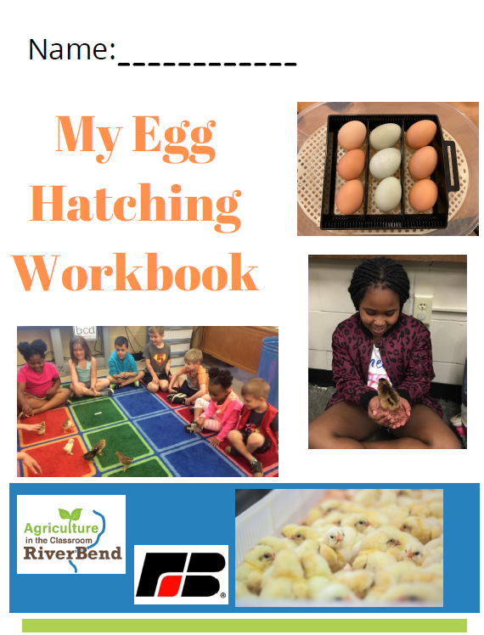

The Egg Calendar
What is happening inside the egg?

Day 1 | Day 2 | Day 3 | Day 4 | Day 5 | Day 6
Day 7 | Day 8 | Day 9 | Day 10 | Day 11 | Day 12
Day 13 | Day 14 | Day 15 | Day 16 | Day 17 | Day 18
Day 19 | Day 20 | Day 21 | Day 22 | Day 23 | Day 24
Day 25 | Day 26 | Day 27 | Day 28 | Day 29 | Day 30

THE LIFE CYCLE OF A CHICK

Draw a picture of the incubator:

What is an incubator?
____________________________________________________________
----------------------------------------------------------------------------------------------------
____________________________________________________________

____________________________________________________________
----------------------------------------------------------------------------------------------------
____________________________________________________________

____________________________________________________________
----------------------------------------------------------------------------------------------------
____________________________________________________________

____________________________________________________________
----------------------------------------------------------------------------------------------------
____________________________________________________________

THE LIFE CYCLE OF A CHICK

Draw a picture of a chick:

Write a sentence about hatching chicks.
____________________________________________________________
----------------------------------------------------------------------------------------------------
____________________________________________________________

____________________________________________________________
----------------------------------------------------------------------------------------------------
____________________________________________________________

____________________________________________________________
----------------------------------------------------------------------------------------------------
____________________________________________________________

____________________________________________________________
----------------------------------------------------------------------------------------------------
____________________________________________________________

COMPARE AND CONTRAST

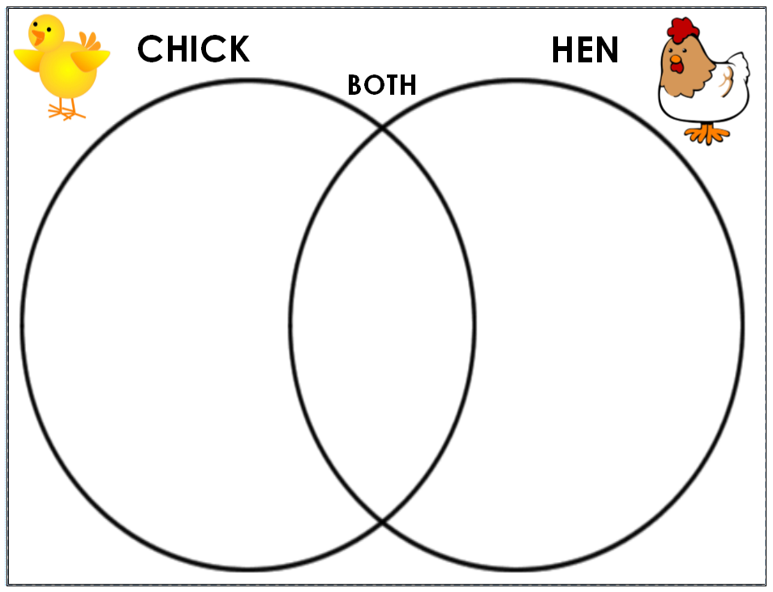
Write a sentence describing the chick and hen:
____________________________________________________________
----------------------------------------------------------------------------------------------------
____________________________________________________________

____________________________________________________________
----------------------------------------------------------------------------------------------------
____________________________________________________________

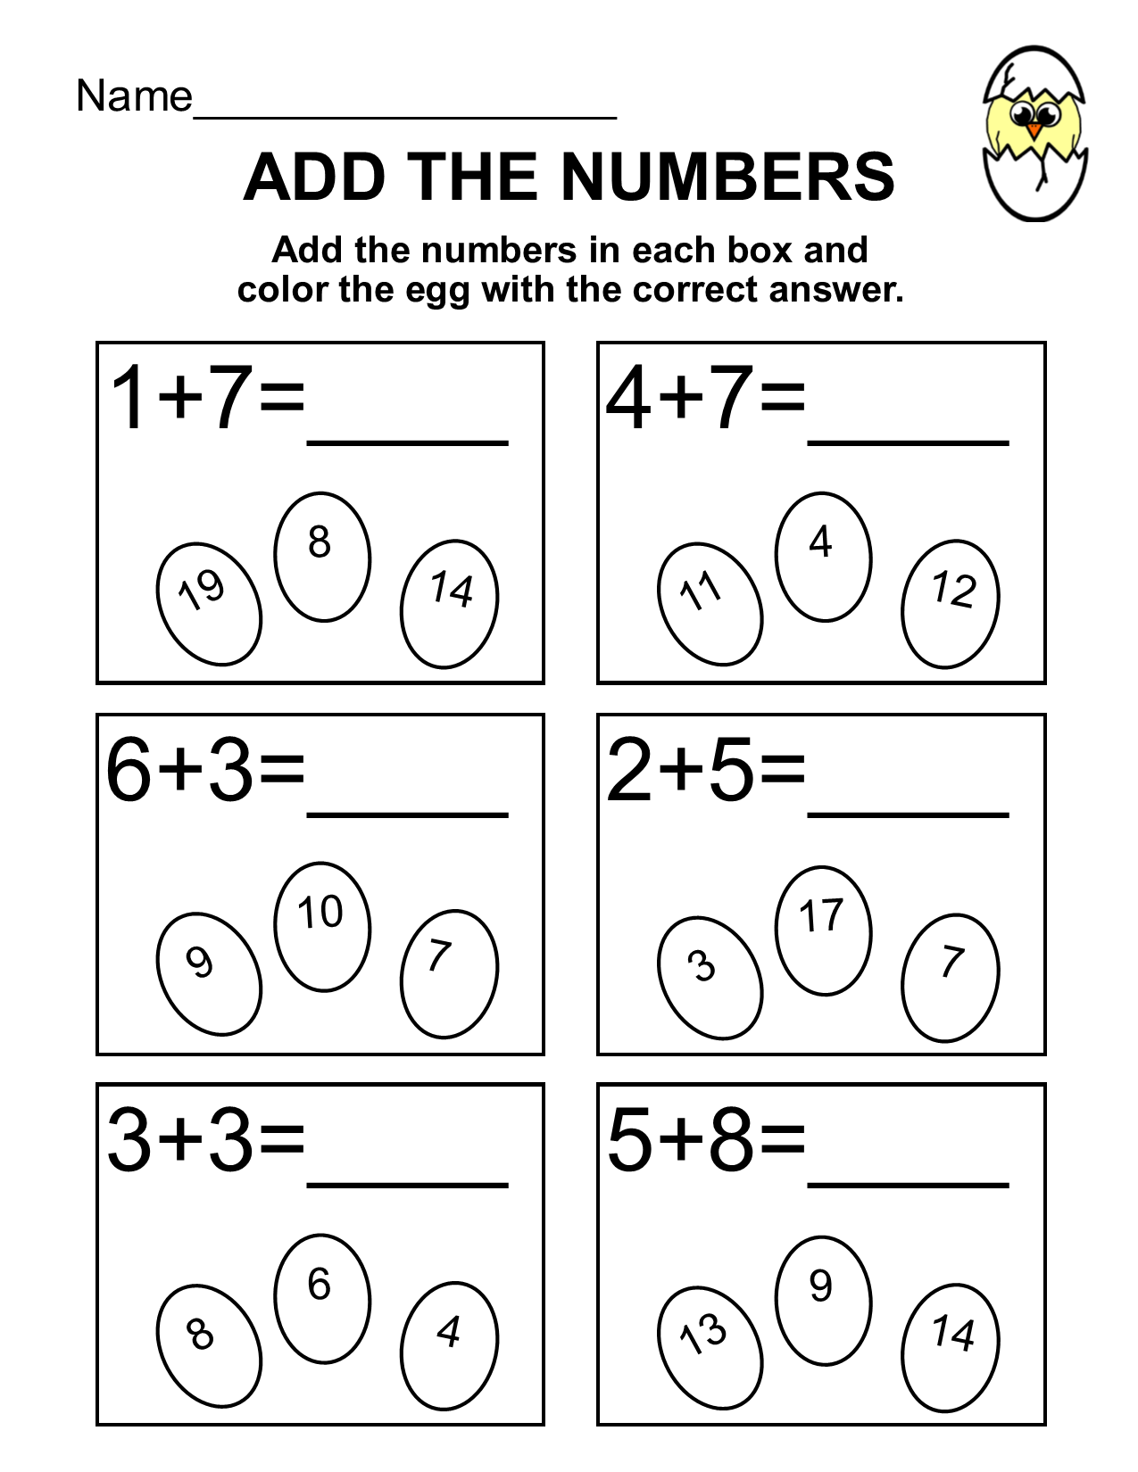

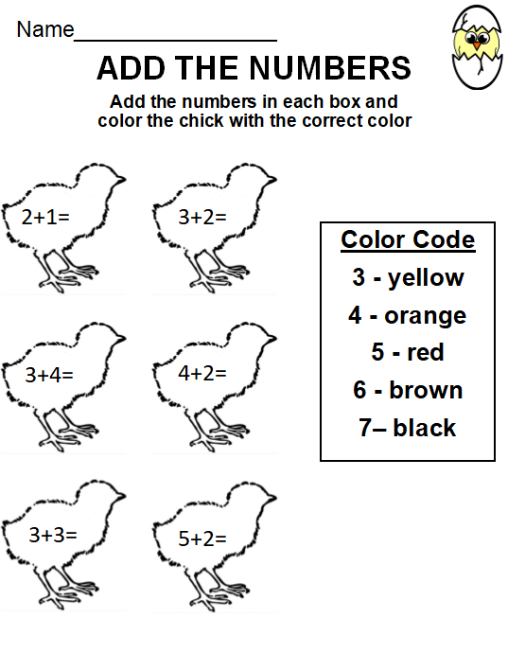

COLOR THE ADULT CHICKEN

