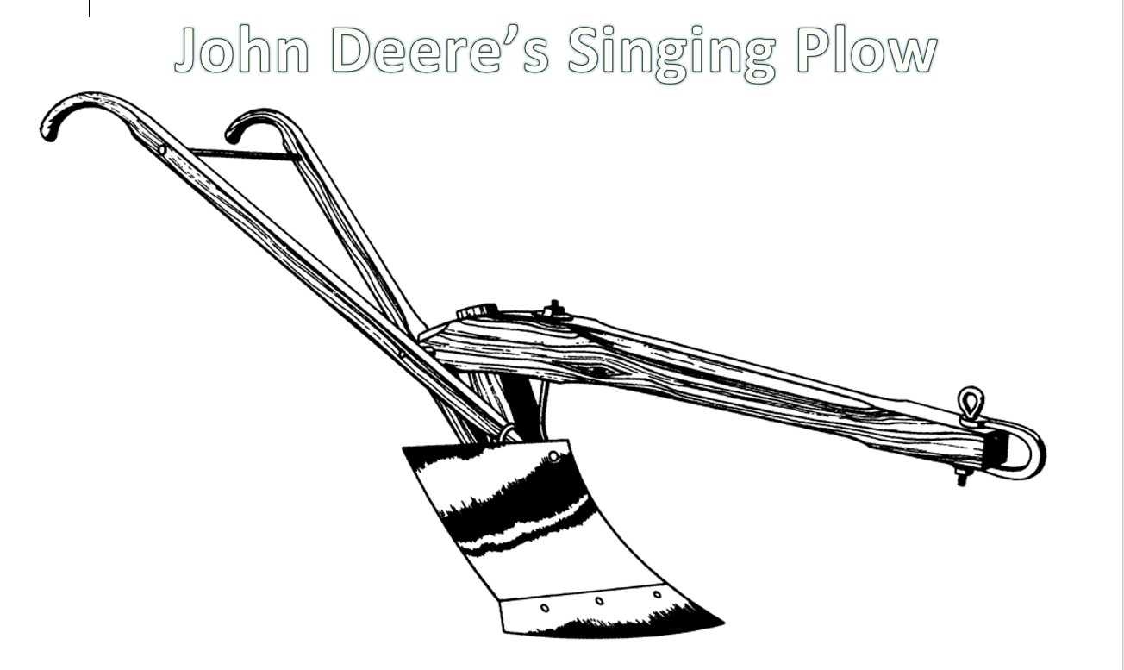
Make Soil Paint!
Mix soil and glue together to color John Deere’s Singing Plow

